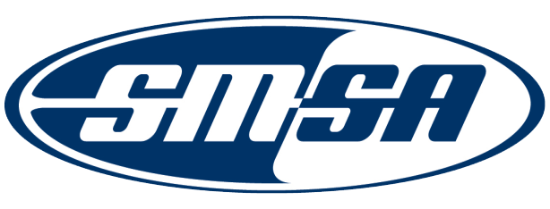
Nomination for the
2012 SMSA Outstanding State Award

The SMSA Award Committee is seeking nominations for the 2012 SMSA Outstanding State Award. This is a new Award that recognizes a state with a comprehensive state motorcycle safety program (NHTSA Highway Safety Program Guideline No. 3 – Motorcycle Safety Program ) and has implemented strategies that are successful, effective and can be measured, evaluated and serve as best practices.

All nominations shall be submitted no later than May 31, 2012 to office@smsa.org.

Nomination Requirements

Nominations shall include:

- A detailed description of the state’s comprehensive program;
- A description of the 2011 and 2012 motorcycle safety strategies;
- A description of how the strategies are measured and evaluated; and
- A description how the strategies impacted the motorcycle safety program

Nomination Cover Sheet – State Award

Nominator’s Contact Information

Nominator Name: ______________________________________________
Address: ______________________________________________________________________________________________
City: State: ______________ Zip: ____________________________
Organization Nominator Represents: ______________________________________________________________
Position Held: ________________________________________________________________________________________
Phone: _______________________________________ Email: ______________________________________

